
Student Name: RONNY MIRARA
Admission Number: BSCCS\2024\53811
Course: Bachelor of Science in Computer Science
Unit Code: BIT4139
Unit Name: ETHICAL HACKING AND COUNTER MEASURES
Lecturer Name: MR MICHAEL NYORO
Semester/Academic Year: SEM 2 YEAR 3

Contents
WEEK ONE 4
WEEK 2 7
WEEK 3 8
WEEK 4 9
Week 5 10
TASK 12
Week 6 15
PRACTICAL TASK 1 15
15
PRACTICAL TASK 2 16
PRACTICAL TASK 3 18
CHALLENGE TASK 20
STUDENT REFLECTION 22
WEEK 7 23
PRACTICAL TASK 1 23
PRACTICAL TASK 2 26
PRACTICAL TASK 3 28
ADVANCED PROGRAMMING TASK 30
WEB SECURITY CHECKLIST 30
CREATIVE TASK 31

Figure 1 Kali linux succesful installation 5
Figure 2 Initialization of isolated Host-Only network interface in VirtualBox. 6
Figure 3 IP Address 6
Figure 4 Validation of virtual network connectivity and successful host discovery. 7
Figure 5 Vulnerability assessment via Nmap Scripting Engine 8
Figure 6 social engineering foot printing in microsoft 9
Figure 7 DNS foot printing microsoft 9
Figure 8 SMNP Enumeration 11
Figure 9 LDAP Enumeration 11
Figure 10 SMTP Enumeration 12
Figure 11 Domain register and IP Address 13
Figure 12 IP Address of the server 14
Figure 13 Open Ports and Services 14
Figure 14 Leaked Credentials 14
Figure 15 successful identified a vulnerable input field 15
Figure 16 Active host scan 16
Figure 17 Identification of open ports 16
Figure 18 login page 28
Figure 19 Admin user role 28
Figure 20cross site output scripting 28
Figure 21 Oswap zap output 29
Figure 22 checklist programme 31
Figure 23 checklist 31

WEEK ONE
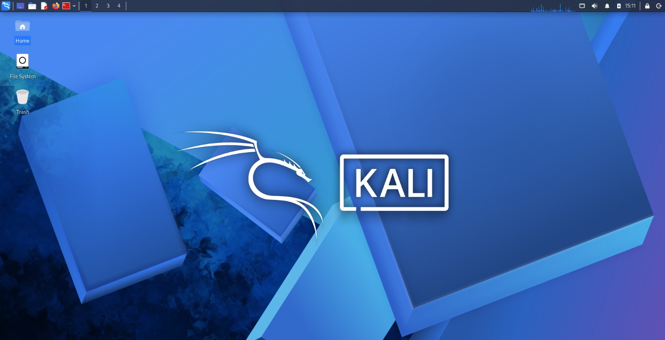
Figure 1 Kali linux succesful installation

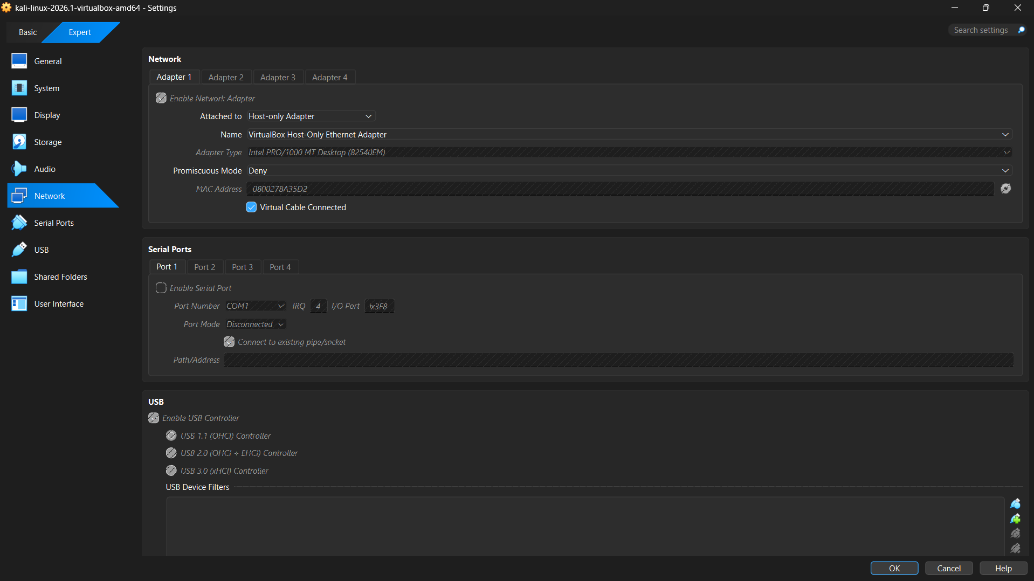
Figure 2 Initialization of isolated Host-Only network interface in VirtualBox.
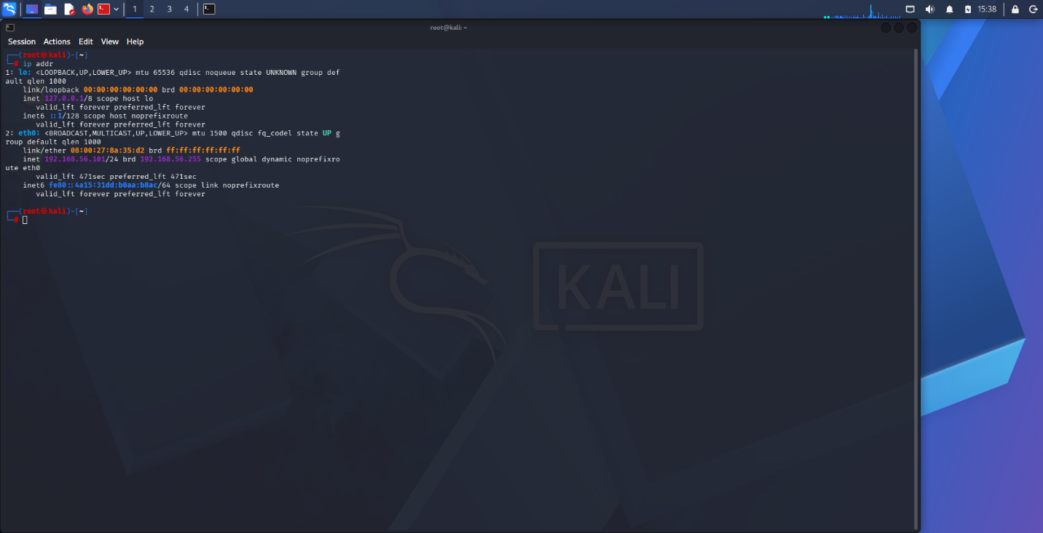
Figure 3 IP Address
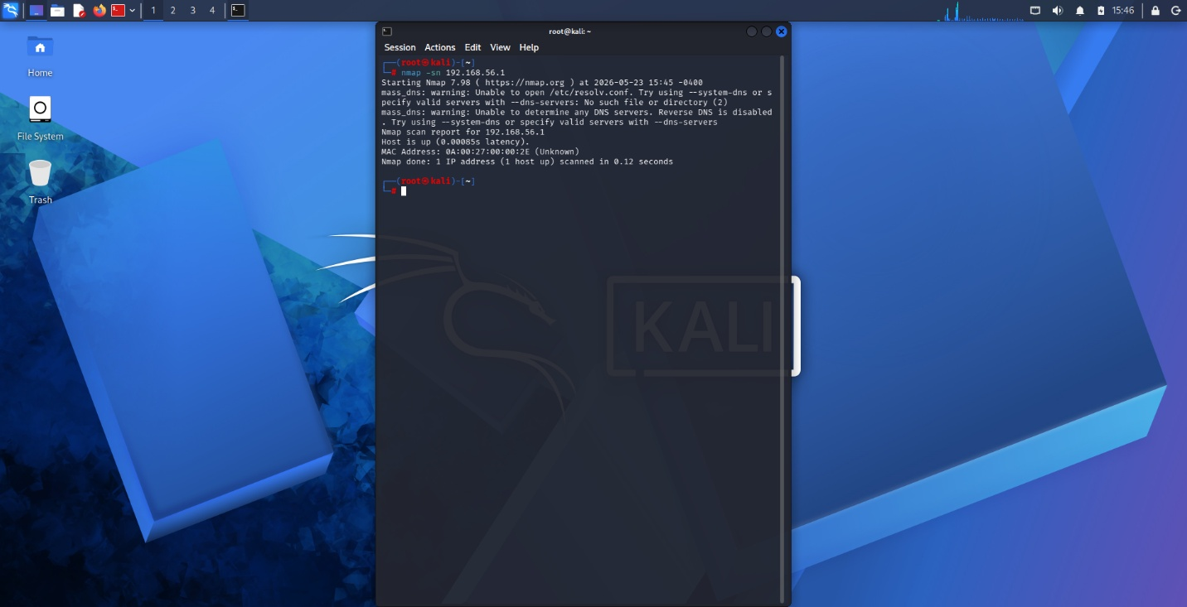
Figure 4 Validation of virtual network connectivity and successful host discovery.
STUDENT REFLECTION
I checked that my two machines were talking to each other by confirming my virtual machine had an assigned IP address. Then I used Nmap to ping the Windows host which proved it was visible and responsive within our private network

WEEK 2
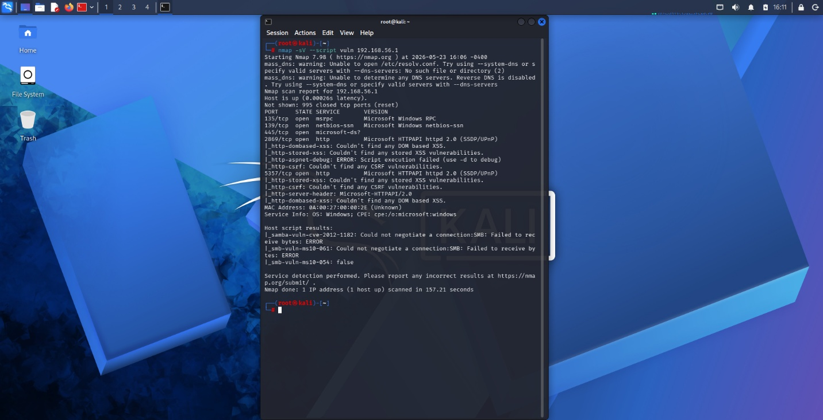
Figure 5 Vulnerability assessment via Nmap Scripting Engine
STUDENT REFLECTION
A vulnerability scan was executed against identified services to check for known security flaws. Results indicate that while services are reachable, the host firewall is actively filtering several threats.

WEEK 3
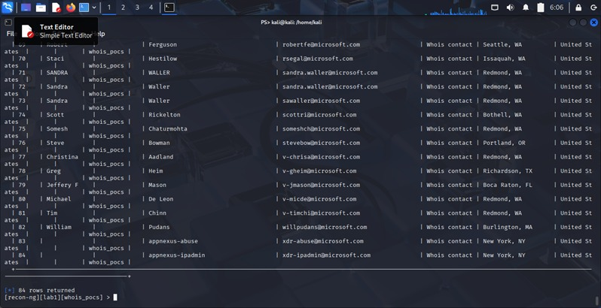
Figure 6 social engineering foot printing in microsoft
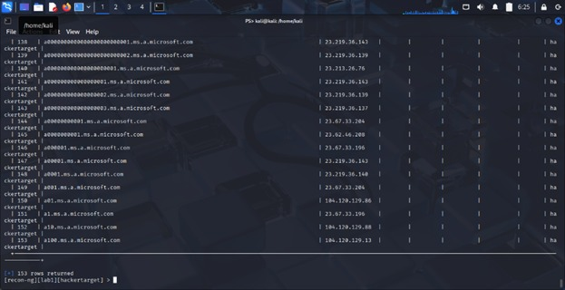
Figure 7 DNS foot printing microsoft
STUDENT REFLECTION
I was able to get information of the system without having to interact with the system . I was able to get the sub domains of the main domain

WEEK 4
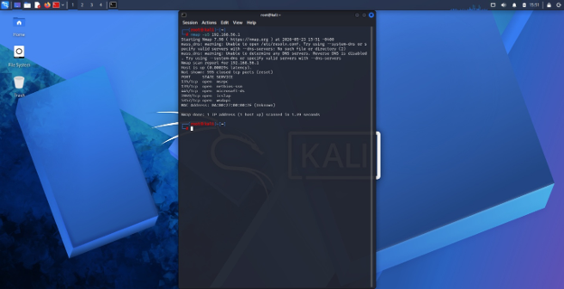
STUDENT REFLECTION
I scanned the target machine to see which ports were left open. By finding ports 135, 139, 445, 2869, and 5357, I created a map of the potential entry points

Week 5
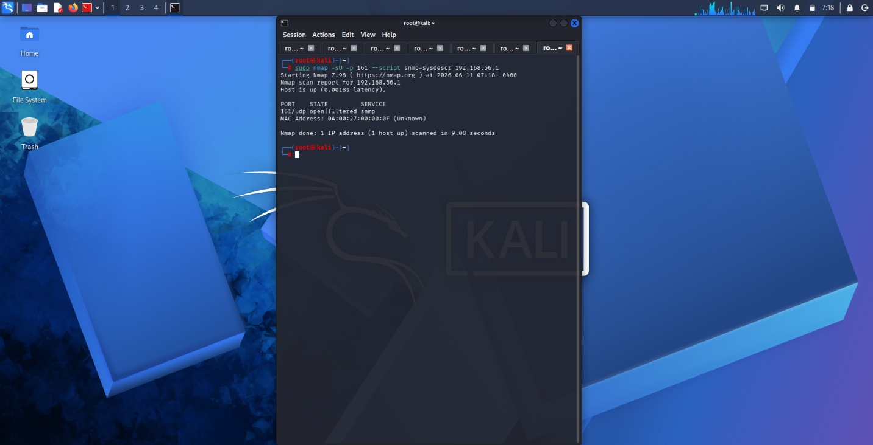
Figure 8 SMNP Enumeration
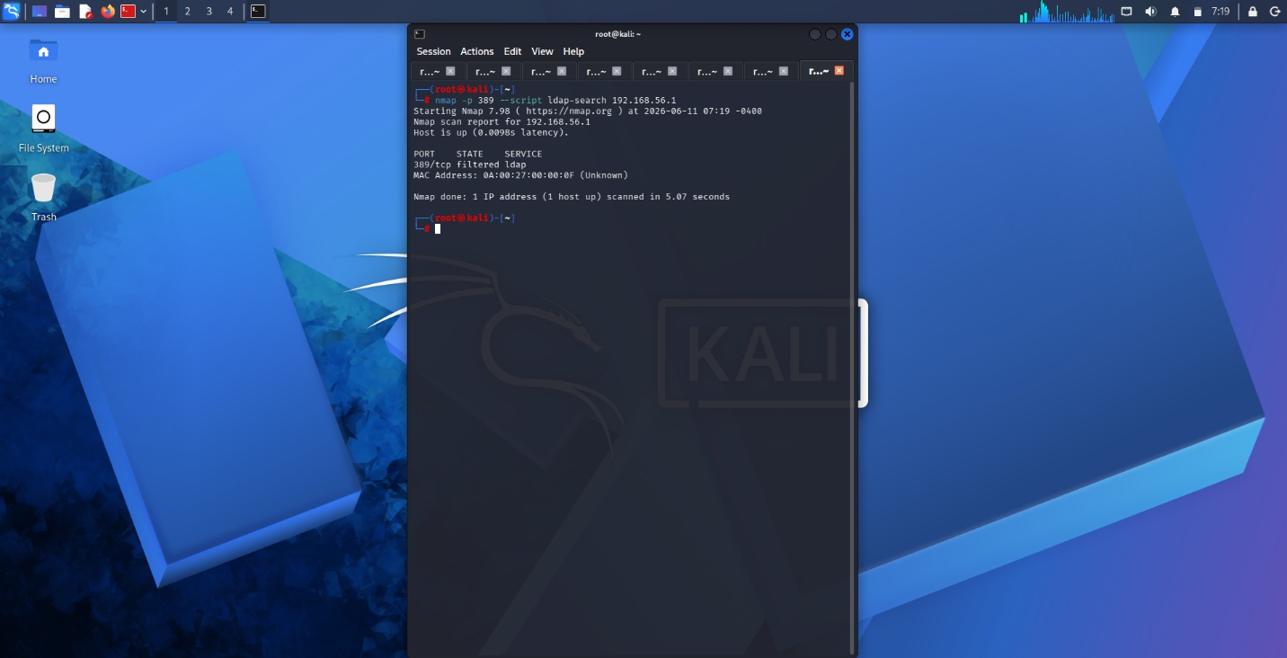
Figure 9 LDAP Enumeration
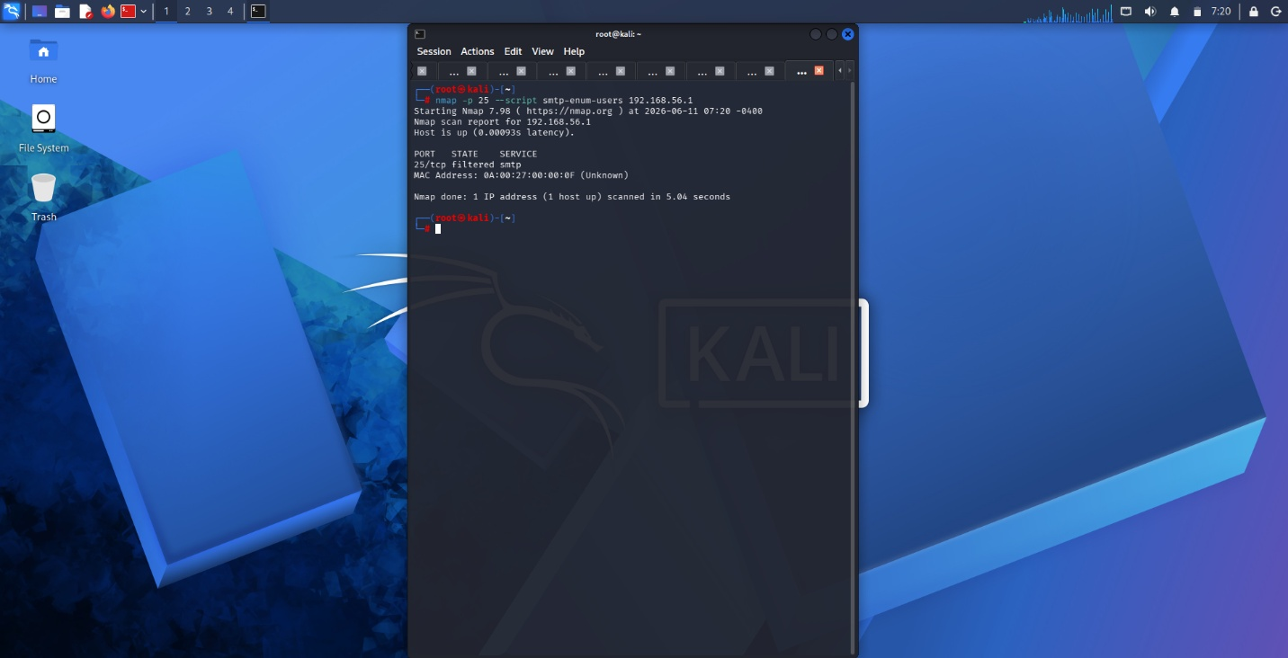
Figure 10 SMTP Enumeration
Performing SNMP enumeration showed me how a single misconfigured community string like public can leak deep system architecture data without needing a password. Investigating LDAP enumeration taught me the dangers of allowing 'anonymous binds' on a directory service. Seeing how an unauthenticated connection to TCP port 389 can allow a user to map out an entire active directory structure. Investigating LDAP enumeration taught me the dangers of allowing 'anonymous binds' on a directory service. Seeing how an unauthenticated connection to TCP port 389 can allow a user to map out an entire active directory structure. Testing SMTP enumeration opened my eyes to how default mail commands like VRFY and EXPN can be abused to map out valid corporate email addresses

TASK
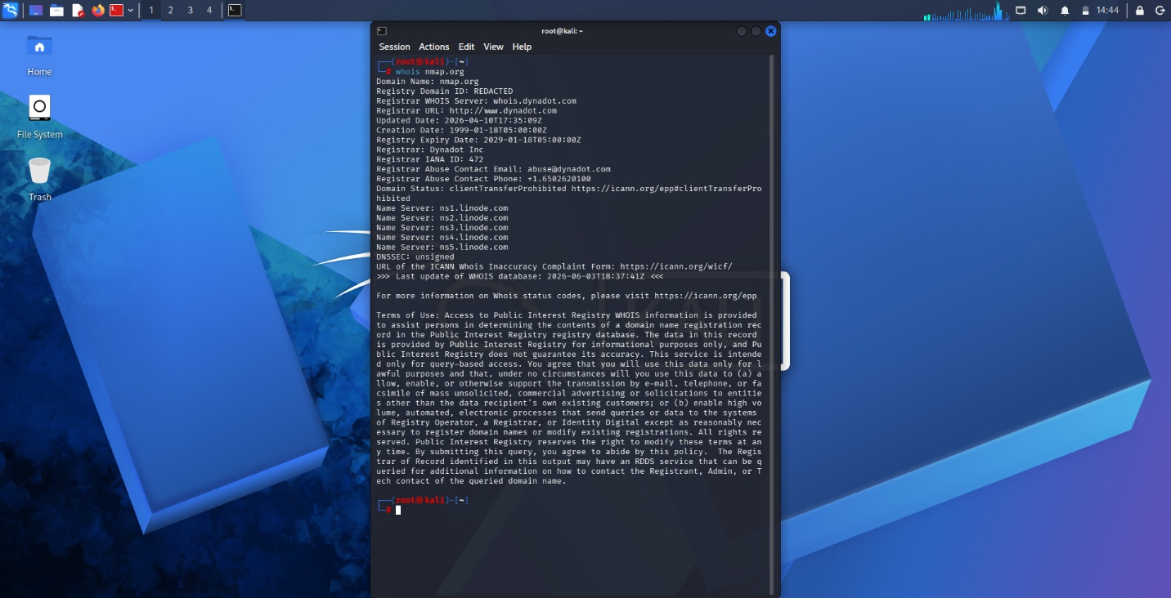
Figure 11 Domain register and IP Address
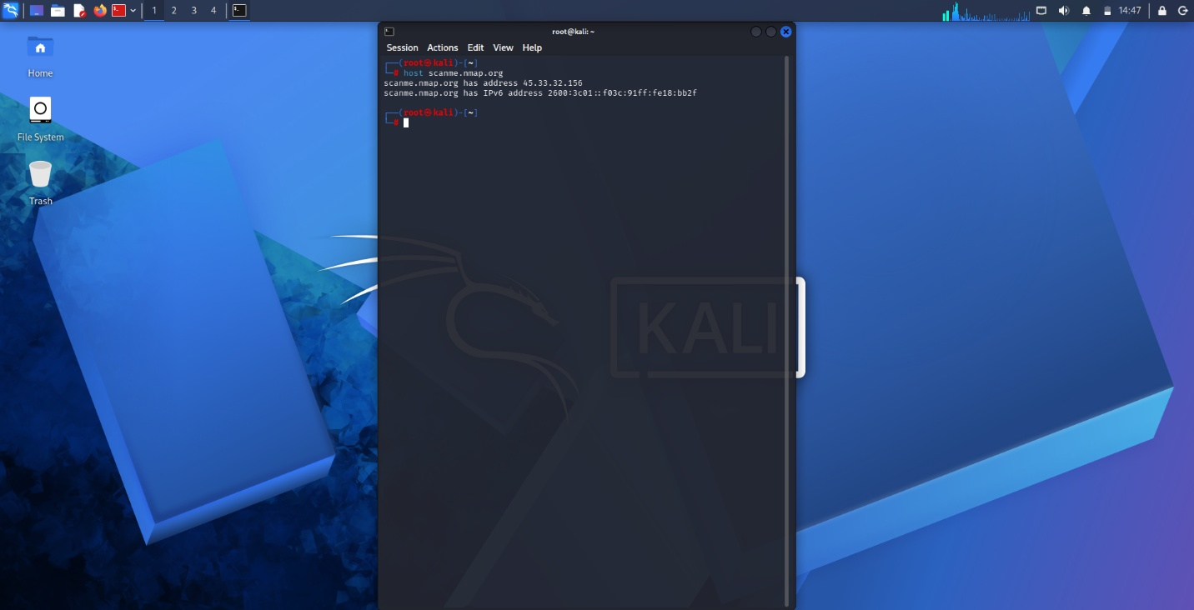
Figure 12 IP Address of the server
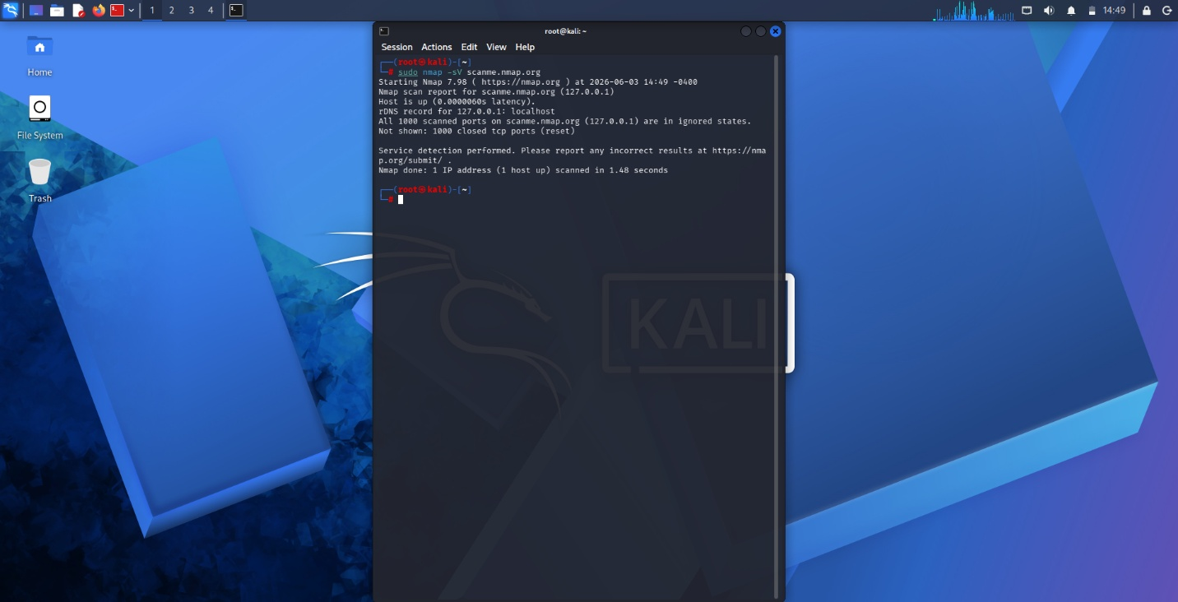
Figure 13 Open Ports and Services
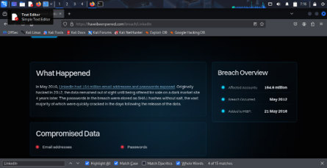
Figure 14 Leaked Credentials
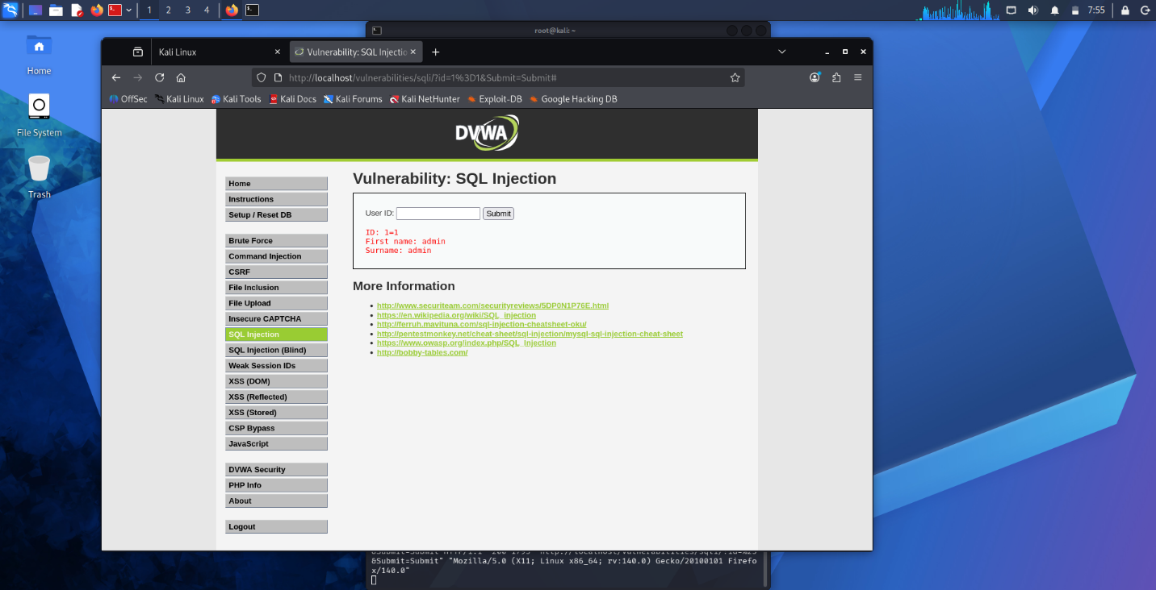
Figure 15 successful identified a vulnerable input field

STUDENT REFLECTION
Using nmap it enabled me to find open ports like port 80 and 21and detect the running services I also was able to attack the back end of a website and able to configure the allow myself to see the users that are using the said website their username and password used.

Week 6

PRACTICAL TASK 1

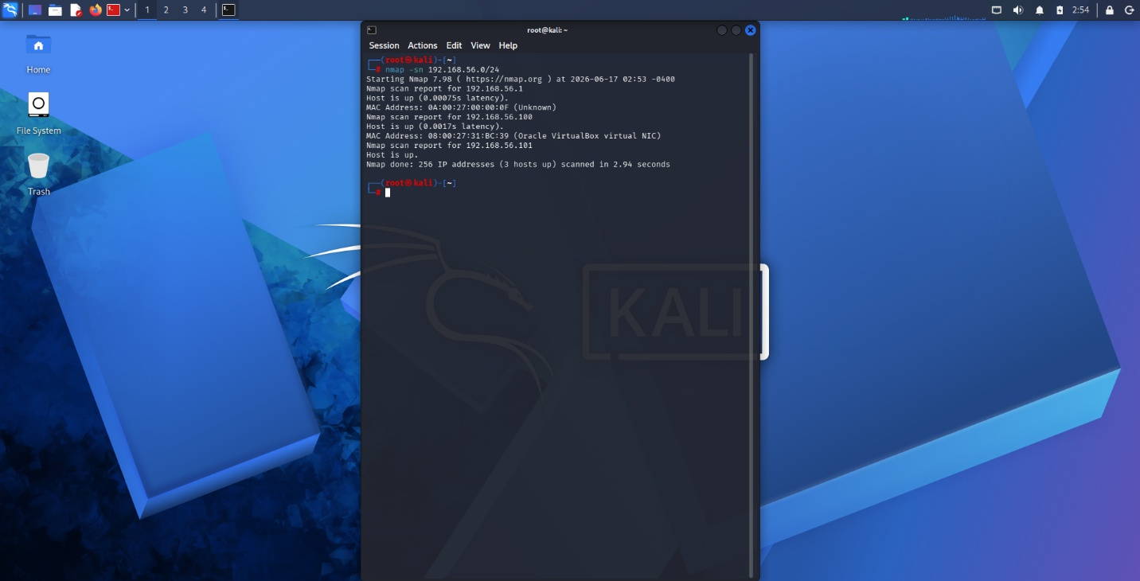
Figure 16 Active host scan
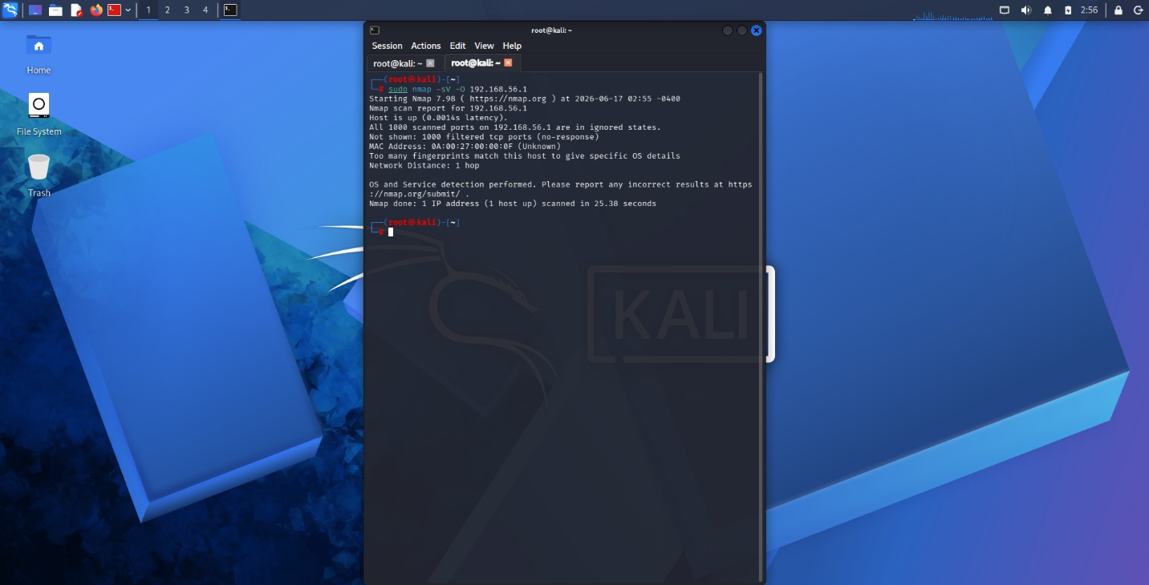
Figure 17 Identification of open ports
A scan of the lab network (192.168.56.0/24) found three active hosts. The primary target (192.168.56.1) demonstrated strong perimeter security, successfully blocking all external scanning attempts via an active firewall
0 open. All 1,000 scanned ports are filtered
OS & Services: Unidentified. The strict firewall prevented Nmap from fingerprinting the TCP/IP stack.
Recommended Security Improvements Because the target system is currently exhibiting a highly secure external posture by dropping unauthorized scanning traffic, the recommendations focus on maintaining and validating these defenses.

PRACTICAL TASK 2
1. XZ Utils Supply Chain Backdoor
CVE Number: CVE-2024-3094
Description: A highly sophisticated, multi-year supply chain attack resulted in a malicious backdoor being embedded directly into XZ Utils, a widely used open-source data compression library in Linux distributions. The backdoor targets the sshd process.
Severity: Critical (CVSS Score: 10.0)
Potential Impact: Remote Code Execution (RCE). The backdoor intercepts the SSH authentication process, allowing an unauthenticated remote attacker to send hidden commands and gain full root control over the affected Linux system.
Mitigation Strategy: Immediately downgrade XZ Utils to a known safe version (such as 5.4.6 Stable). System administrators must follow vendor-specific guidance for their exact Linux distribution (e.g., Debian, Fedora, Kali) to revert the packages and audit for compromise.
2. Palo Alto PAN-OS GlobalProtect Command Injection
CVE Number: CVE-2024-3400
Description: A severe command injection vulnerability exists in the GlobalProtect gateway feature of Palo Alto Networks PAN-OS software. It is caused by improper input validation combined with an arbitrary file creation flaw.
Severity: Critical (CVSS Score: 10.0)
Potential Impact: Unauthenticated Remote Code Execution. An attacker can execute arbitrary commands with root privileges directly on the firewall. This allows them to disable security features, access sensitive data, and use the firewall as a pivot point to attack the internal network.
Mitigation Strategy: Apply the official firmware patches released by Palo Alto Networks immediately. If patching cannot be done right away, temporary workarounds include applying vulnerability protection signatures or temporarily disabling vulnerable GlobalProtect features.
3. Microsoft Windows TCP/IP IPv6 Vulnerability
CVE Number: CVE-2024-38063
Description: A "zero-click" remote code execution flaw located deep within the Windows TCP/IP networking stack. The vulnerability specifically affects how the operating system processes IPv6 traffic.
Severity: Critical (CVSS Score: 9.8)
Potential Impact: Remote Code Execution. An attacker can repeatedly send specially crafted IPv6 packets to a Windows machine, enabling them to execute arbitrary code. Because it is a zero-click vulnerability, no user interaction or authentication is required for the attack to succeed.
Mitigation Strategy: Apply the official Microsoft security updates provided in the August 2024 Patch Tuesday release. If immediate patching is impossible, disabling IPv6 on the affected network adapters serves as a temporary mitigating workaround.
4. Ivanti Connect Secure Command Injection
CVE Number: CVE-2024-21887
Description: A command injection vulnerability affecting the web components of Ivanti Connect Secure and Ivanti Policy Secure gateways. It is frequently exploited in the wild by chaining it with an authentication bypass flaw (CVE-2023-46805).
Severity: Critical (CVSS Score: 9.1)
Potential Impact: Remote Code Execution. When chained with the bypass, an unauthenticated remote attacker can execute arbitrary system commands. This provides a trusted entry point into the network, leading to data exfiltration, lateral movement, and the deployment of persistent webshells.
Mitigation Strategy: Apply the official patches provided by Ivanti. Critically, before applying the patch, administrators must run the internal Ivanti Integrity Checker Tool to verify if the appliance has already been compromised by threat actors.
5. Fortra GoAnywhere MFT Authentication Bypass
CVE Number: CVE-2024-0204
Description: An authentication bypass vulnerability found in Fortra's GoAnywhere Managed File Transfer (MFT) software (versions prior to 7.4.1).
Severity: Critical (CVSS Score: 9.8)
Potential Impact: Authentication Bypass / Privilege Escalation. An unauthorized remote attacker can bypass the administrative portal's login mechanism and create a brand-new administrative user. This grants them elevated access to sensitive corporate data, file transfer workflows, and configuration settings.
Mitigation Strategy: Upgrade the GoAnywhere MFT application to version 7.4.1 or higher. In environments where upgrading is delayed (and not using container deployments), a temporary fix involves manually deleting the InitialAccountSetup.xhtml file from the installation directory and restarting the service.

PRACTICAL TASK 3
1. University Network
Universities are notoriously difficult to secure due to the massive volume of unmanaged student devices (BYOD) and open-access culture mixed with highly sensitive research data.
- Scope: Internal academic networks, student registration/grading portals (e.g., VLMS), staff workstations, and research data servers. Explicitly excluded: Personal student devices connected to the guest Wi-Fi.
- Tools: Nmap (network mapping), Nessus or OpenVAS (infrastructure scanning), and Burp Suite (for testing student/faculty web portals).
- Schedule: Biannual comprehensive scans scheduled during winter and summer academic breaks to minimize disruption. Continuous automated scanning on critical research and financial subnets.
- Reporting Procedure: A high-level executive summary delivered to the University Board focusing on institutional risk, accompanied by a detailed technical remediation report for the IT department, prioritizing grading systems and research servers.
2. Small Business
Small businesses generally have limited IT budgets, smaller attack surfaces, and prioritize keeping their daily operations running without interruption.
- Scope: Point of Sale (POS) terminals, employee workstations, the customer-facing website, and the local Wi-Fi network.
- Tools: Nessus Essentials (cost-effective scanning), Nmap, and Nikto (basic web server scanning).
- Schedule: Quarterly automated vulnerability scans, preferably run after business hours or on weekends to avoid slowing down customer transactions.
- Reporting Procedure: A simplified, non-technical risk report presented directly to the business owner or manager. The report should prioritize quick, low-cost fixes (like updating router firmware or changing default passwords) that prevent immediate business disruption.
3. Hospital
Hospitals are high-stakes environments where an aggressive network scan can accidentally knock a fragile medical device (like an MRI or heart monitor) offline, directly threatening patient safety. Strict HIPAA compliance is also required.
- Scope: Electronic Health Records (EHR) databases, administrative networks, and Medical IoT devices.
- Tools: Passive network sniffers like Wireshark (crucial to map medical devices without sending active probes that might crash them), Nessus (for the administrative side), and specialized healthcare vulnerability scanners.
- Schedule: Continuous passive monitoring of the medical device network. Monthly active scans on the administrative network during strict, predefined low-traffic maintenance windows.
- Reporting Procedure: A formal compliance-driven report focusing on HIPAA violations and patient data exposure. Critical vulnerabilities affecting medical hardware must trigger an immediate, out-of-band alert to the Chief Information Security Officer (CISO) and hospital administration.
4. Financial Institution
Banks and financial institutions face the highest level of active threat actors and operate under strict financial regulations (like PCI-DSS for credit card processing).
- Scope: Core banking infrastructure, SWIFT transfer terminals, ATM networks, customer online banking applications, and employee endpoints.
- Tools: Enterprise-grade scanners like Qualys or Tenable, Burp Suite Professional for deep web application testing, and SQLmap for testing database security on the backend of banking portals.
- Schedule: Continuous, 24/7 automated vulnerability management. Quarterly deep-dive penetration testing to satisfy financial regulatory requirements.
- Reporting Procedure: Highly formalized reporting that maps directly to regulatory frameworks (like PCI-DSS). The report must include an executive summary for the Board of Directors regarding financial risk, and a segmented technical report for the security operations center (SOC) for immediate patching of critical transactional systems.

CHALLENGE TASK
This phase establishes the baseline of the network.
- Continuous Discovery: Utilize active network scanning (e.g., Nmap ping sweeps) and passive traffic analysis to detect rogue or unmanaged devices connecting to the network.
- Centralized CMDB: Maintain a Configuration Management Database (CMDB) that logs the IP, MAC address, OS, software stack, and physical location of every asset.
- Asset Classification: Assign a business criticality tier to every asset:
  - Tier 1 (Mission Critical): Public-facing web servers, Active Directory, customer databases.
  - Tier 2 (Important): Internal employee workstations, file servers.
  - Tier 3 (Standard): Guest Wi-Fi routers, non-critical IoT devices.
2. Scanning Schedule
Scanning frequency is dictated by the asset's classification tier to balance network load with security needs.
- Tier 1 (Mission Critical): Continuous agent-based scanning; weekly active credentialed network scans.
- Tier 2 (Important): Bi-weekly credentialed scans.
- Tier 3 (Standard): Monthly uncredentialed network sweeps.
- Event-Driven Scans: Immediate, ad-hoc scans triggered by major infrastructure changes, new software deployments, or zero-day threat alerts (e.g., a newly announced vulnerability in a firewall).
3. Risk Assessment Process
Not all vulnerabilities with a "Critical" score pose a critical risk to your specific organization. Risk must be contextualized.
- Base Scoring: Utilize the Common Vulnerability Scoring System (CVSS) provided by the scanner to establish a baseline severity.
- Contextual Evaluation: Adjust the priority based on environmental factors:
  - Is the vulnerable asset exposed to the public internet? (Increases risk).
  - Is there a compensating control in place, like a strict firewall rule? (Decreases risk).
  - Is there active exploit code available in the wild? (Immediate escalation).
- Prioritization Matrix: Combine the CVSS score with the Asset Classification Tier to determine the final remediation priority.
4. Patch Management & Remediation
This phase dictates how quickly the IT team must fix the identified flaws.
- Service Level Agreements (SLAs): Strict deadlines for applying patches based on the final risk priority:
  - Critical Risk: Remediate within 48 hours.
  - High Risk: Remediate within 7 to 14 days.
  - Medium Risk: Remediate within 30 days.
  - Low Risk: Remediate within 90 days (or during standard quarterly maintenance).
- Testing & Rollout: Patches must be deployed to an isolated staging environment first to ensure they do not break business applications. Once verified, they are rolled out to production.
- Risk Acceptance: If a patch breaks a legacy system and cannot be applied, management must formally sign a "Risk Acceptance" document and implement compensating controls (like moving the asset to an isolated VLAN).
5. Reporting Procedures
Information must be tailored to the audience receiving it.
- Executive Board (Quarterly): High-level metrics focusing on business risk. Includes the overall risk posture trend, average time to remediate critical vulnerabilities, and budget justifications for new security tools.
- Security & IT Managers (Monthly): Department-level compliance reports. Highlights which teams are meeting their patching SLAs and which are falling behind.
- Security Operations Center (Daily/Weekly): Highly technical, granular lists of specific CVEs, affected IPs, and exact patch deployment instructions.
6. Continuous Monitoring
Vulnerability management is a loop, not a one-time project.
- Endpoint Agents: Deploy lightweight agents (like Nessus Agent or CrowdStrike) on workstations and servers to provide real-time vulnerability data without waiting for the next scheduled network scan.
- SIEM Integration: Feed vulnerability scanner logs directly into the Security Information and Event Management (SIEM) system. If an intrusion detection system spots an attack aimed at a server, the SIEM can instantly check if that server is vulnerable to the specific attack.
- Threat Intelligence Feeds: Subscribe to global threat feeds (like CISA alerts) to proactively identify new vulnerabilities in the organization's software stack before the vendor's official patch is even released.

STUDENT REFLECTION
Designing the Vulnerability Management Framework taught me that security is a continuous lifecycle, not a one-time fix. I learned to prioritize technical flaws by contextualizing them with asset criticality and business risk. Establishing strict patching SLAs showed me how organizations effectively bridge the gap between discovery and remediation.

WEEK 7

PRACTICAL TASK 1

1: Broken Access Control
- Definition: Flaws that allow users to act outside of their intended permissions. The system fails to enforce policies that restrict what authenticated users are allowed to do.
- Example: A standard user manipulates a URL from app.com/user_profile to app.com/admin_dashboard and is granted access to the administrative control panel without an admin account.
- Impact: Attackers can view sensitive files, modify other users' data, change access rights, or completely take over the application administration.
- Prevention: Deny access by default. Implement robust Role-Based Access Control (RBAC) on the server-side, rather than relying on hiding links in the client-side user interface.
2: Cryptographic Failures
- Definition: The failure to adequately protect sensitive data (such as passwords, credit card numbers, or health records) either while it is stored (at rest) or transmitted across a network (in transit).
- Example: A database stores user passwords in plain text or uses an outdated, easily cracked hashing algorithm like MD5, allowing anyone who dumps the database to instantly read the credentials.
- Impact: Exposure of sensitive information resulting in identity theft, financial fraud, or mass credential harvesting.
- Prevention: Encrypt all sensitive data at rest. Enforce modern transport layer security (TLS) for data in transit. Use strong, salted hashing algorithms (like Argon2 or bcrypt) for passwords.
3: Injection
- Definition: Occurs when untrusted, un-sanitized user data is sent to an interpreter as part of a command or query, tricking the backend system into executing unintended commands.
- Example: Submitting a payload like %' or '1'='1 into a web application's user ID search box to manipulate the backend MySQL logic and dump the entire database to the screen.
- Impact: Complete data loss, corruption, unauthorized disclosure of entire database structures, or denial of access.
- Prevention: Use parameterized queries (prepared statements) in PHP and other backend languages. Strictly validate, filter, and sanitize all user-supplied input.
4: Insecure Design
- Definition: Vulnerabilities caused by fundamental architectural flaws rather than simple coding errors. The application was built without threat modeling or secure design principles from the start.
- Example: A cinema booking website allows users to select seats for a movie but fails to lock those seats in the database during the checkout process, allowing multiple people to purchase the exact same seat simultaneously.
- Impact: Severe business logic bypasses, financial loss, and critical workflow failures that cannot be fixed by a simple patch.
- Prevention: Integrate formal threat modeling into the Software Development Life Cycle (SDLC). Establish and enforce secure design patterns before code is written.
5: Security Misconfiguration
- Definition: Flaws resulting from insecure default settings, incomplete configurations, open cloud storage buckets, or verbose error messages containing sensitive system details.
- Example: Leaving an SNMP service exposed on UDP port 161 with the default community string set to "public", allowing unauthenticated network scanning to map the host.
- Impact: Unauthorized system access, complete host compromise, or severe information leakage.
- Prevention: Implement a hardened, repeatable build process for all servers. Remove unused features, disable default accounts/passwords, and turn off verbose error reporting in production environments.
6: Vulnerable and Outdated Components
- Definition: Utilizing software modules, libraries, frameworks, or operating systems that contain known security vulnerabilities or are no longer supported by their developers.
- Example: Running a Linux server utilizing a version of the xz-utils compression library that contains a known, critical supply-chain backdoor (CVE-2024-3094).
- Impact: Depending on the compromised component, impacts range from minor data leaks to unauthenticated Remote Code Execution (RCE) and total server takeover.
- Prevention: Maintain a continuous Software Bill of Materials (SBOM) to track all application dependencies. Implement strict patch management schedules for all components.
7: Identification and Authentication Failures
- Definition: Weaknesses in how an application verifies a user's identity, manages user sessions, or handles credential recovery.
- Example: A web portal lacks rate limiting, allowing an automated script to submit thousands of password guesses per minute until it successfully brute-forces an account.
- Impact: Attackers compromise passwords, encryption keys, or session tokens to fully assume the identities of legitimate users.
- Prevention: Implement Multi-Factor Authentication (MFA). Enforce strong password complexity rules. Ensure session IDs are securely generated, timed out after inactivity, and invalidated upon logout.
8: Software and Data Integrity Failures
- Definition: When code, infrastructure, or deployment pipelines do not verify the integrity of software updates, critical data, or CI/CD processes. This includes insecure deserialization.
- Example: An application automatically downloads and installs a firmware update from an unencrypted HTTP server without verifying a digital signature, allowing an attacker to intercept the connection and inject a malicious payload.
- Impact: Execution of unauthorized code, compromised continuous integration pipelines, and widespread malware distribution.
- Prevention: Ensure all software updates, libraries, and external dependencies are cryptographically signed and verified before execution. Secure CI/CD pipelines with strict access controls.
9: Security Logging and Monitoring Failures
- Definition: The failure to properly log security-critical events or actively monitor those logs, creating blind spots that allow attacks to occur unnoticed.
- Example: A server database is continuously probed for SQL injection vulnerabilities over a 48-hour period, but because failed queries are not logged or sent to an alerting system, the security team is completely unaware.
- Impact: Attackers can establish persistent footholds, extract data over long periods, and destroy forensic evidence before defenders even realize a breach has occurred.
- Prevention: Ensure all login, access, and server-side validation failures are securely logged in a format easily readable by centralized monitoring solutions (like a SIEM). Establish active alerting thresholds.
10: Server-Side Request Forgery (SSRF)
- Definition: Occurs when a web application fetches a remote resource based on a user-supplied URL without validating the destination. This forces the server to make requests on the attacker's behalf.
- Example: An attacker uses a web application's image-fetching tool to input an internal network address (e.g., http://192.168.56.1/admin_panel), bypassing external firewalls to interact directly with internal, protected infrastructure.
- Impact: Internal network scanning, exposure of internal metadata, and potential remote code execution on internal servers that trust the compromised web application.
- Prevention: Enforce strict "allow lists" for permitted network destinations. Validate and sanitize all client-supplied input URLs. Isolate the application's network access to prevent it from reaching sensitive internal subnets.

PRACTICAL TASK 2

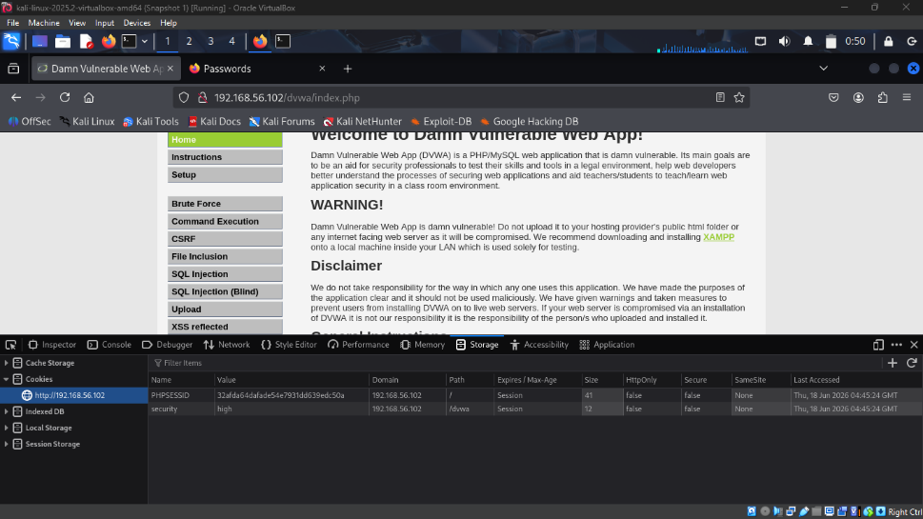
Figure 18 login page
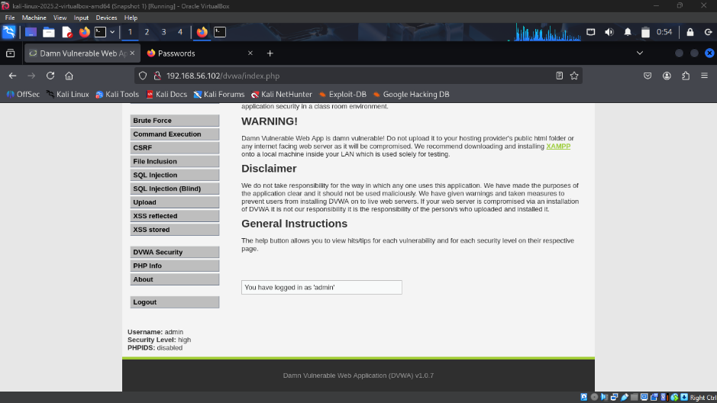
Figure 19 Admin user role
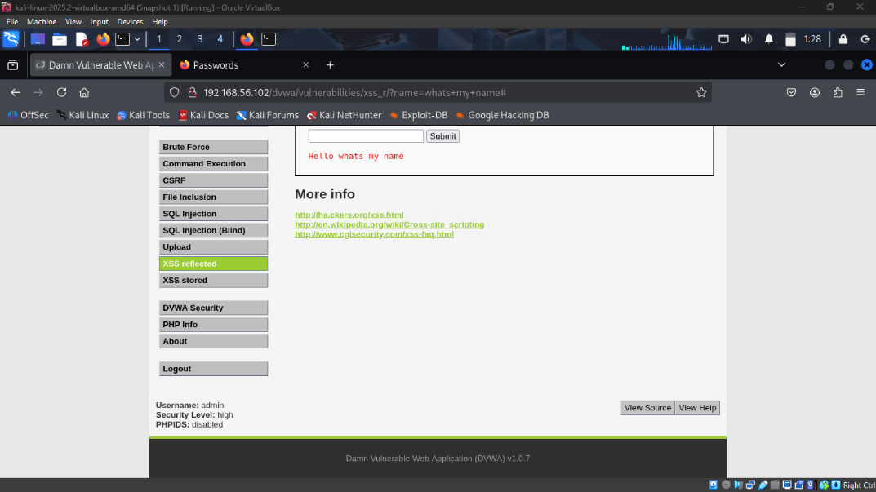
Figure 20cross site output scripting
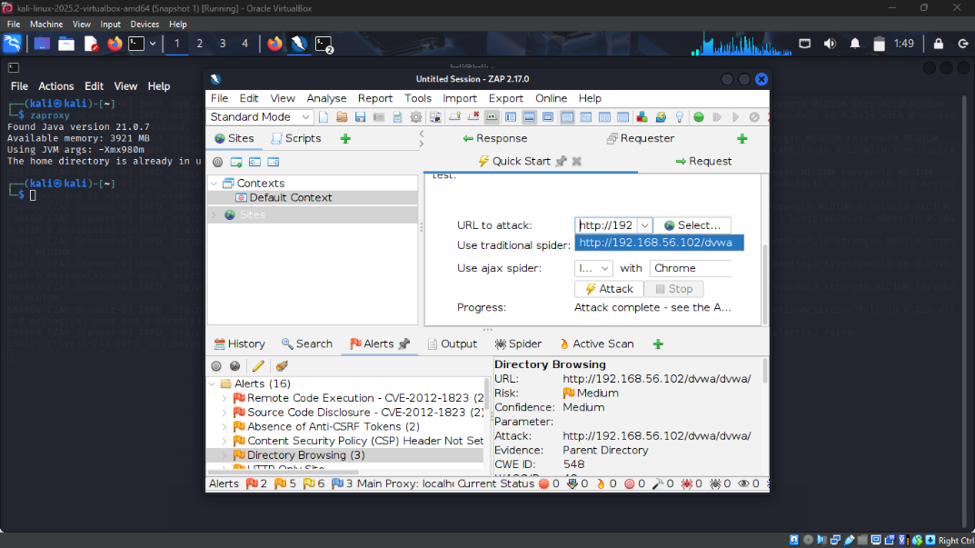
Figure 21 Oswap zap output

PRACTICAL TASK 3
1. Authentication Controls To mitigate identity-based attacks (such as credential stuffing and brute-force attacks), the following controls must be implemented:
- Multi-Factor Authentication (MFA): Mandate MFA (via authenticator app or hardware token) for all administrative accounts immediately, with a phased rollout for standard users.
- Rate Limiting & Account Lockout: Implement strict rate limiting on all login endpoints (e.g., maximum of 5 failed attempts per minute). Enforce a 15-minute account lockout after 5 consecutive failed login attempts to neutralize brute-force tools.
- Password Policies: Enforce a minimum password length of 12 characters and check newly created passwords against known compromised password databases (e.g., using the HIBP API).
2. Input Validation Measures To neutralize injection attacks (SQLi, XSS) and malicious file uploads, the application must adopt a "zero-trust" approach to user input:
- Strict Server-Side Validation: All input must be validated on the backend. Client-side JavaScript validation is for user experience only and must not be relied upon for security.
- Parameterized Queries: Rewrite all database interactions to use prepared statements/parameterized queries, completely eliminating the possibility of SQL Injection.
- File Upload Hardening: Restrict file uploads to a strict allow-list of MIME types (e.g., application/pdf). Rename all uploaded files upon receipt, remove executable permissions, and store them in an isolated AWS S3 bucket or a directory strictly outside the application's web root.
3. Logging Mechanisms Proper logging is required to detect active attacks and conduct post-incident forensics:
- Comprehensive Event Logging: The application must log all authentication successes/failures, privilege changes, password resets, and high-value data access (e.g., viewing a sensitive contract).
- Log Integrity: Logs must be stored in an append-only format and shipped immediately to a centralized Security Information and Event Management (SIEM) server to prevent attackers from wiping their tracks if the web server is compromised.
- Active Alerting: Configure the SIEM to trigger alerts to the Security Operations Center (SOC) if anomalous behavior occurs, such as multiple IDOR attempts or a spike in 404/500 HTTP error codes.
4. Patch Management Strategy To prevent exploitation of known vulnerabilities in third-party software (like the OWASP A06 risk):
- Software Bill of Materials (SBOM): Generate and maintain an active SBOM to track every open-source library and dependency used by the web application.
- Automated Dependency Scanning: Integrate Software Composition Analysis (SCA) tools into the CI/CD pipeline to automatically block code deployments if a dependency contains a "High" or "Critical" CVE.
- Routine Maintenance Window: Establish a strict 14-day Service Level Agreement (SLA) for applying critical security patches to the web server operating system and underlying frameworks.

ADVANCED PROGRAMMING TASK

WEB SECURITY CHECKLIST
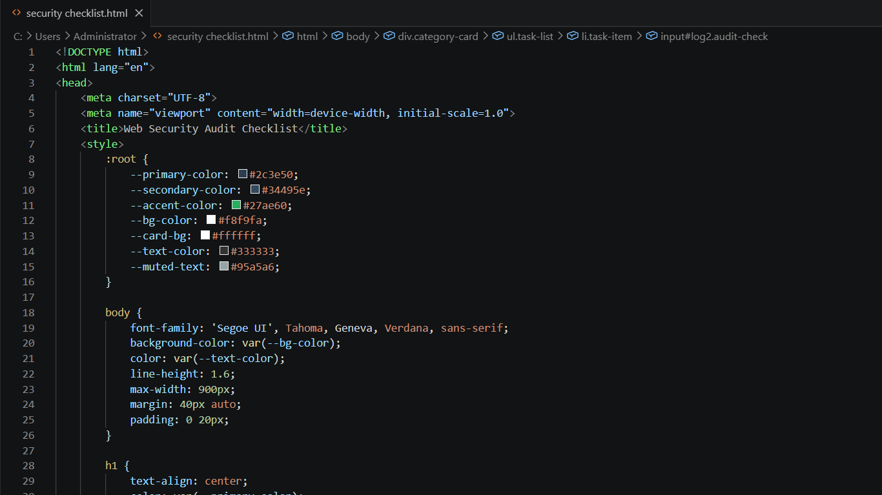
Figure 22 checklist programme
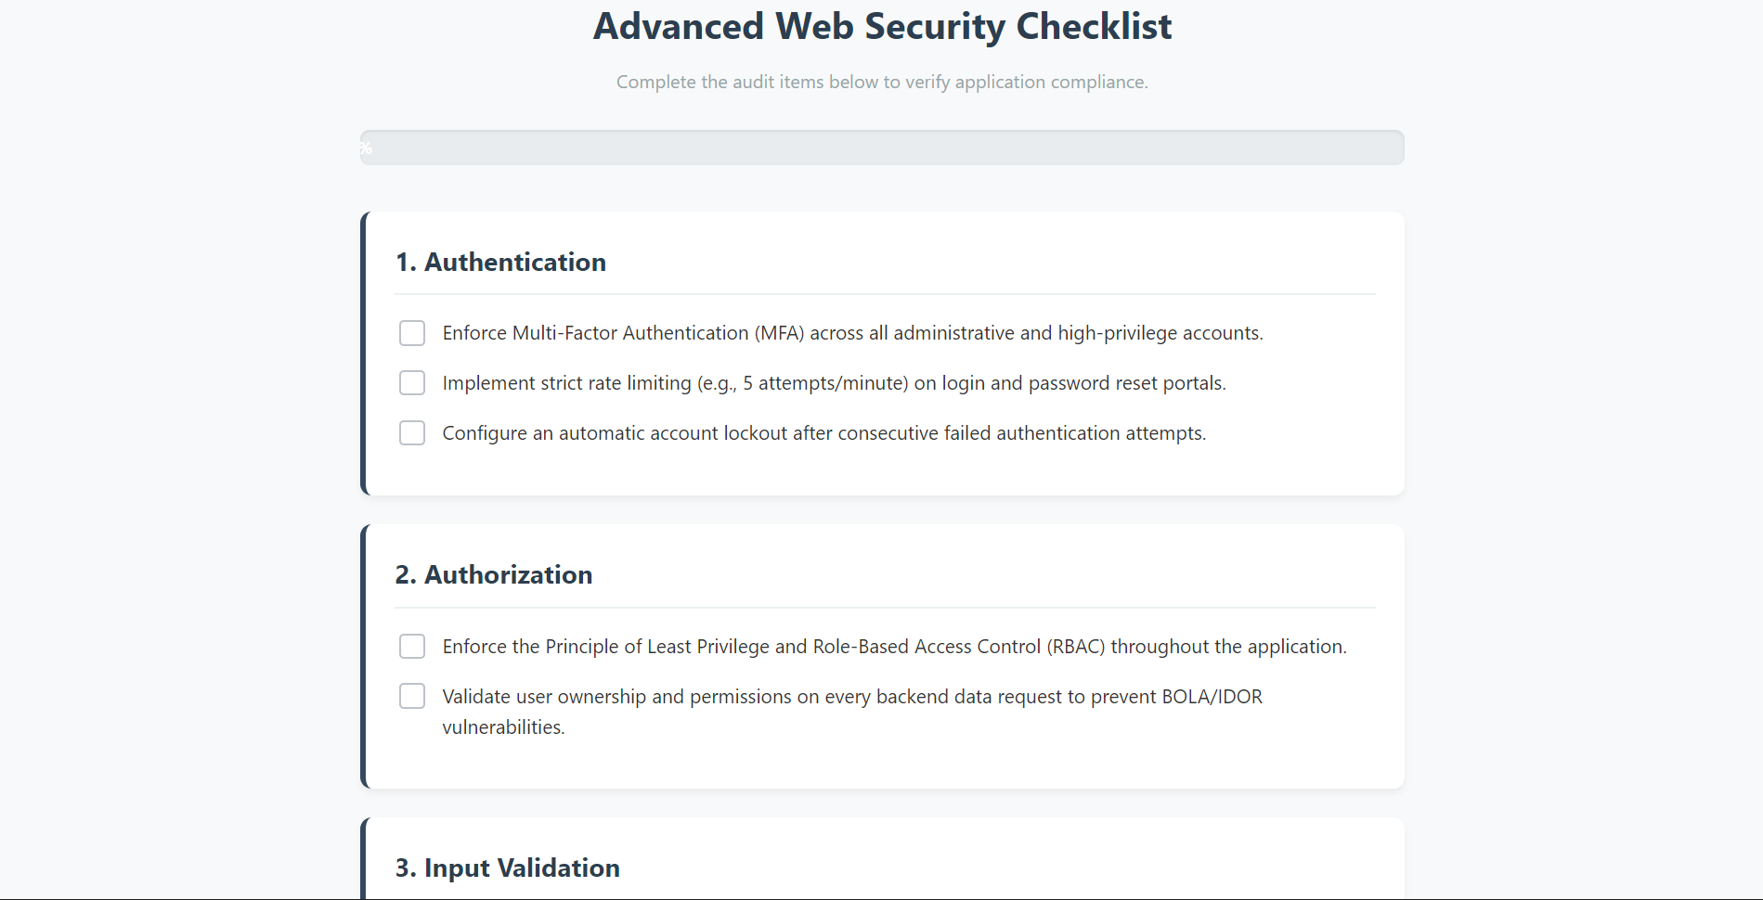
Figure 23 checklist

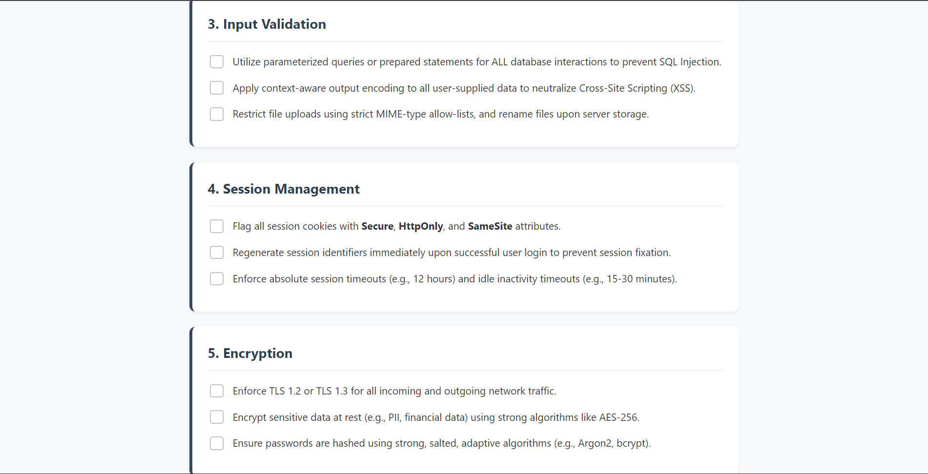
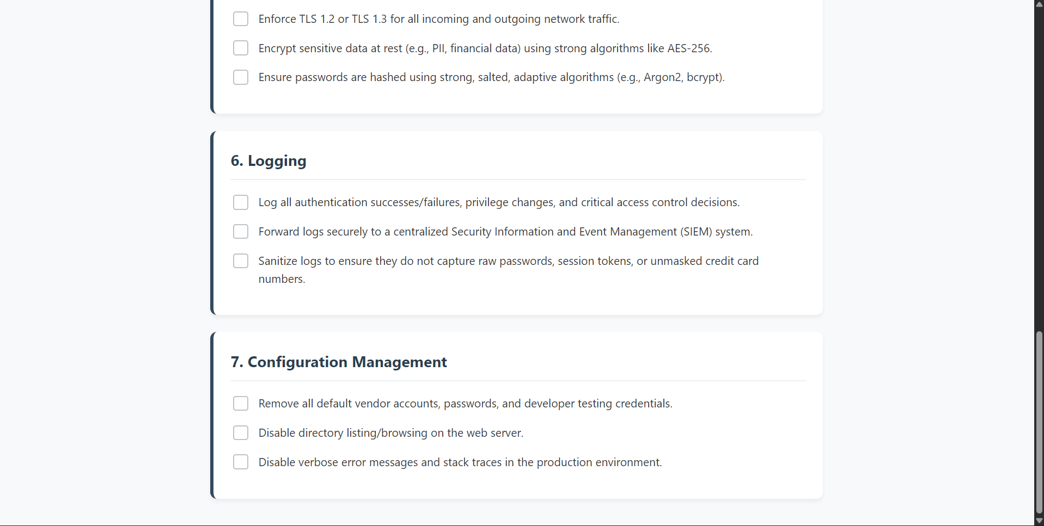

CREATIVE TASK
Secure Web Application Design Framework
1. Security Requirements
- Identity Management: Enforce Multi-Factor Authentication (MFA) and Role-Based Access Control (RBAC) across the application.
- Encryption Standards: Require AES-256 for sensitive data stored in the database (at rest) and TLS 1.3 for all web traffic (in transit).
2. Threat Modeling
- Framework: Use the STRIDE methodology (Spoofing, Tampering, Repudiation, Information Disclosure, Denial of Service, Elevation of Privilege) during the design phase.
- Data Flow: Map out Data Flow Diagrams (DFDs) to identify "trust boundaries" where user data interacts with the backend database.
3. Secure Coding Practices
- Zero-Trust Input: Validate all user input on the server side to block malicious payloads.
- Injection Prevention: Strictly mandate the use of Parameterized Queries (Prepared Statements) for all database calls to completely prevent SQL Injection.
- XSS Prevention: Enforce context-aware output encoding so browsers do not accidentally execute malicious scripts.
4. Testing Procedures
- Automated Scans: Integrate SAST (Static Application Security Testing) to scan source code as it is written, and DAST (Dynamic Application Security Testing) to scan the compiled, running application.
- Manual Testing: Require an authenticated penetration test using intercepting proxies before the application goes live.
5. Deployment Controls
- Secrets Management: Forbid developers from hardcoding passwords or API keys in the source code. Require a centralized vault (like AWS Secrets Manager).
- Pipeline Security: Enforce automated security gates in the CI/CD pipeline that block deployment if a "High" or "Critical" vulnerability is detected.
6. Monitoring and Incident Response
- Centralized Logging: Send all authentication logs and error codes to a secure SIEM (Security Information and Event Management) system.
- Response Plan: Maintain a documented Incident Response playbook that defines exact steps for isolating the web server in the event of an active breach.

